TOPIC 1 - INTRODUCTION

Q1. Find the First Palindromic String
Aim:
To identify the first palindromic string in a given list of words using string reversal logic. Algorithm:
- Read an array of strings.
- For each word, reverse it.
- Compare the reversed string with the original.
- Return the first match found.
- If no palindrome exists, return an empty string.
CODE:
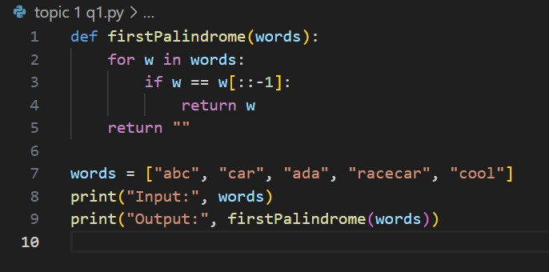

Input & Output:
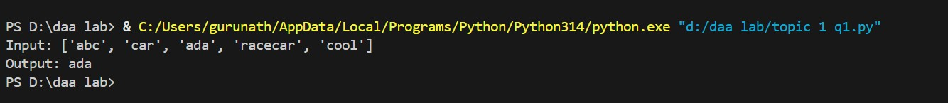

Result: The program successfully finds _{"ada"} as the first palindrome.

Q2. Find Common Elements Between Two Arrays
Aim:
To count how many elements in one array appear in another.

Algorithm:
- Read arrays _{nums1} and _{nums2}.
- For each element in _{nums1}, check if it exists in _{nums2}.
- Maintain counters for both arrays.
- Use sets to improve efficiency.
- Return [count1, count2].
CODE:
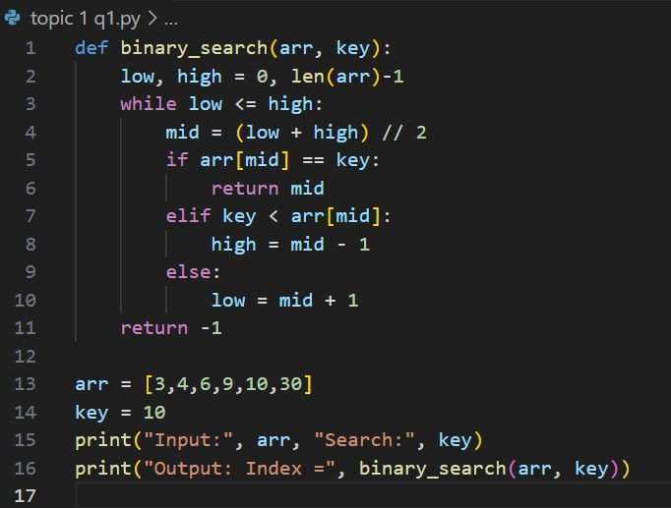
Input & Output:

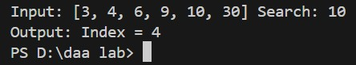

Result: Both arrays are compared and mutual occurrences are counted.

Q3. Binary Search on Sorted Array
Aim:
To locate a target element efficiently in a sorted array using divide-and-conquer logic. Algorithm:
- Initialize _{low} = 0 and _{high} = n − 1.
- Find _{mid} = (low + high)/2.
- If _{arr[mid]} = key, return index.
- If key < arr[mid], search left subarray.
- Else, search right subarray.
CODE:
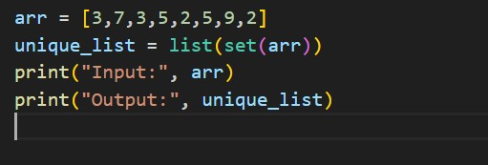
Input & Output
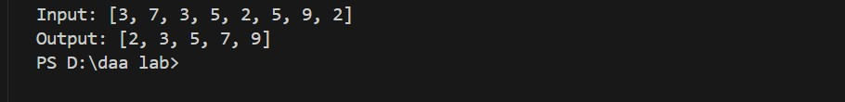

Result: Binary search locates the key efficiently in logarithmic time.

Q4. Sort and Find Maximum Element
Aim:
To sort a list using efficient sorting and find its maximum element. Algorithm:
- Read the list.
- Sort using an algorithm like merge sort or quick sort.
- Retrieve last element as maximum.
- Handle empty list condition.
- Print result.
CODE:
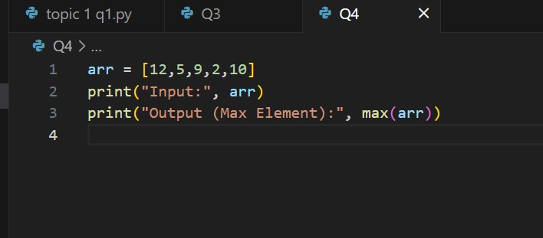

Input & Output:
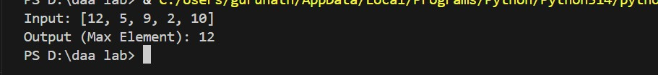

Result: Sorted list and maximum element displayed correctly.

Q5. Unique Elements Extraction
Aim:
To remove duplicates from a list and retain unique elements. Algorithm:
- Read input list.
- Create an empty set.
- Traverse each element; add to set if not already present.
- Convert set to list.
- Display unique list.
CODE:
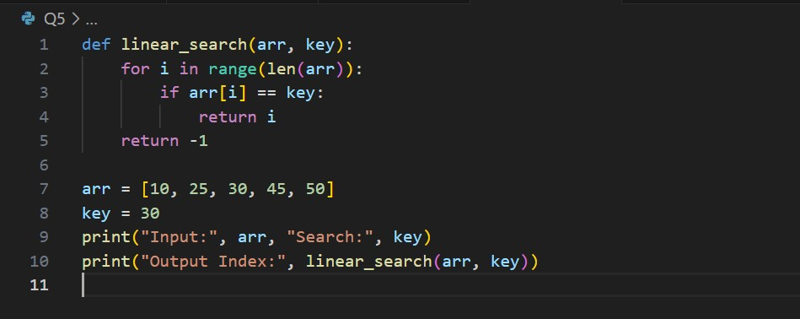

Input & Output:

Result: Duplicate elements removed successfully.

